1. Inside the fhe file ‘index.jsp’ remove the user <input> element and its associated <label> element and add 2 new <input> elements ‘First Name’ and ‘Last Name’. Create <label> elements for these inputs.
2. Add a submit button element.

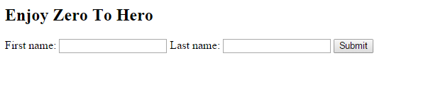

1. For the <form> element from ‘index.jsp’ change the action attribute to ‘/zerotohero’.
2. Create a new Servlet named ‘ZeroToHeroServlet’.
3. Create a private method ‘handleRequest’ which takes as argument a HttpServletRequest object named ‘req’ and return a String object.
4. Inside the ‘handleRequest’ method create a String object ‘response’ with the following value: "Hello <b>[firstName] [lastName]</b>! Enjoy Zero To Hero!!!" where [firstName] and [lastName] will represent the parameters received on request(get them from the HttpServletRequest object).
5. Return from ‘handleRequest’ method the String object created.
6. Override ‘doPost’ method.
7. Inside ‘doPost’ set the Content Type for the response to “text/html”.
8. Inside ‘doPost’ write on the response object the value returned from calling ‘handleRequest’ method. For writing on the response use: resp.getWriter().write(…);
9. Inside ‘web.xml’ configure your new Servlet following the next steps.
10. Create a new Servlet with name ‘ZeroToHero’, description ‘ZeroToHero Servlet’ and class ‘ZeroToHeroServlet’.
11. Create the servlet mapping for this Servlet: put the servlet name for the new created Servlet and map it to ‘/zerotohero’ URL.
12. Run ‘maven clean install’.
13. Run ‘maven tomcat:deploy-only’ under the tomcat plugin.
14. You should see something similar

C:\Users\viorelt\Documents\My Received Files\L_FE1D.tmp.PNG